Malnad College Of Engineering
Under the auspices of M.T.E.S ®
(An Autonomous Institution Affiliated to VTU, Belgaum)
P.B. No. 21, Hassan 573 202, Karnataka

Full Stack Development (23IS505)
TITLE: “Dairy Management Web Application”
Group number: 01

Submitted By:

Name | USN
Dashwanth T R | 4MC23IS028
Girish B | 4MC23IS036
Haneesh H D | 4MC23IS037
Hruthwik M R | 4MC23IS043

Under The Guidance of:
Mr. Krishna Swaroop A Assistant Professor, ISE

Department of Information Science and Engineering Malnad College of Engineering
Hassan - 573 202
2025-2026
Date of submission: 01-12-2025

1 ABSTRACT
The Dairy Management System is a comprehensive, web-based solution developed using Django to streamline and digitalize dairy operations such as product handling, order management, customer interaction, billing, and administrative monitoring. Dairy businesses, especially in India, traditionally depend on handwritten records, registers, and manual tracking of daily tasks. These conventional methods introduce several challenges—errors in data entry, difficulty in maintaining past records, ambiguity in transactions, delayed decision-making, and lack of transparency between the dairy owner and customers.
To overcome these limitations, the proposed system integrates modern web technologies and database management systems. The project leverages Django’s Model-View-Template (MVT) architecture, which enhances modularity, scalability, and maintainability. The admin dashboard offers a consolidated view of total products, order statuses, inventory levels, and quick management actions. Customers benefit from a smooth interface to log in, view products, place orders, and track their order history.
The system significantly reduces manual workloads, increases accuracy in record-keeping, and enhances operational efficiency. The results demonstrate that digitizing dairy operations improves accessibility, transparency, and overall business performance. This project forms the foundation for future improvements such as milk-collection automation, supplier dashboards, IoT-based dairy monitoring, and mobile application integration.

TABLE OF CONTENTS
- Cover Page
- Abstract
- Introduction
3.1 Background of the Problem
3.2 Domain Selection
3.3 Real-World Scenario Description
3.4 Issues in Existing System
3.5 Proposed System Advantages
- Objectives of the Project
- System Requirements
5.1 Software Requirements
5.2 Hardware Requirements
- System Design
6.1 Architecture Diagram
6.2 Architecture Explanation
- Database Design
7.1 ER Diagram
7.2 Database Tables Description
- Implementation
8.1 Models Overview
8.2 Views and Business Logic
8.3 URL Routing
8.4 Templates & User Interface Description
- Screenshots
9.1 Login Page
9.2 Admin Dashboard
9.3 Products Section
9.4 Orders Section
- Testing
10.1 Functional Testing
10.2 Database Testing
10.3 Security & Performance Testing
- Results
- Conclusion
- Future Enhancements
- References

3 INTRODUCTION
3.1 Background of the Problem
The dairy sector plays a major role in India’s economy, constituting a large portion of the agricultural and rural livelihoods. Millions of families rely on dairy production, supplying milk to local dairy units or cooperative societies. Despite technological advancements, several small and medium-scale dairies continue to rely heavily on manual processes like paper-based registers, calculators for recurring payments, and verbal communication for orders.
Such manual systems introduce multiple challenges:
- Data loss due to damaged registers
- Inconsistent milk quantity entries
- Difficulty verifying order details
- Lack of customer transparency
- Time-consuming monthly payment calculations
- No centralized database for long-term data storage
Digitalizing dairy activities helps solve these issues by centralizing data, promoting transparency, and reducing human error.
3.2 Why This Domain Was Chosen
The dairy sector is a blend of traditional processes and the need for technological enhancement. Observing real practices at local dairies revealed common issues such as miscommunication in order deliveries, difficulty tracking customers, and the absence of automated records. This inspired the development of a system that:
- Is simple enough for rural usage
- Requires basic computer knowledge
- Runs in browsers without installation
- Stores data permanently
- Reduces operational inefficiencies
Thus, a Django-based Dairy Management System provides an ideal combination of simplicity and efficiency.
3.3 Real-World Scenario Description
A typical dairy center collects milk twice daily—morning and evening—records product inventory, handles customer orders, and updates stock. Without automation:
- The dairy admin must manually review stock levels
- Customers may not know order status
- Orders may be misplaced
- Record-keeping becomes inconsistent
This system solves such issues by providing:
- Admin login
- Customer login
- Order placement system
- Product management
- Dashboard summaries
- Automated calculations
3.4 Issues in Existing System
Issue | Impact
Manual records | High chances of errors
No backup | Loss of data due to damage
Miscommunication | Inconsistent order management
No customer portal | Poor transparency
No automation | Time-consuming

3.5 How the Proposed System Helps
The Dairy Management System addresses the limitations of manual methods through digitalization:
- Accurate tracking of products
- Real-time order monitoring
- Secure login for customers
- Consolidated admin dashboard
- Reduced data redundancy
- Improved transparency and accessibility
- Automated backend using Django ORM
4. OBJECTIVES OF THE PROJECT
Primary Objectives
- To build a user-friendly online platform for managing dairy operations.
- To allow an admin to control all products, orders, and system data.
- To digitalize product stock management for accurate inventory tracking.
- To simplify customer interactions through an online shopping interface.
- To automate order management and order history storage.
Secondary Objectives
- To provide a secure login system using Django authentication.
- To offer dashboards with accurate real-time statistics.
- To reduce dependency on handwritten registers.
- To minimize human errors in product or order entries.
- To provide a scalable system that can support future modules.

5. SYSTEM REQUIREMENTS
5.1 Software Requirements
Programming Language: Python 3.10+
Framework: Django 4.x
Frontend: HTML5, CSS3, Bootstrap
Database: SQLite (default) or MySQL
IDE/Text Editor: VS Code / PyCharm
Browser: Chrome, Firefox, Edge
Additional Libraries:
- Django ORM
- Crispy Forms
- Pillow (if images used)
- Bootstrap Icons
5.2 Hardware Requirements
Minimum Hardware Needs:
- Processor: Intel i3 or equivalent
- RAM: 4GB minimum, 8GB recommended
- Hard Disk: 500MB for project files
- Display: 14 inch+
- Operating System: Windows / Linux

6. SYSTEM DESIGN
6.1 Architecture Diagram
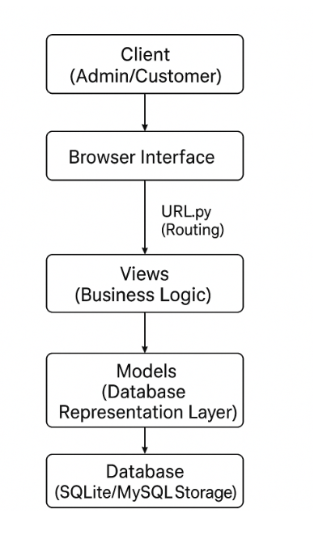

6.2 Explanation of Architecture Components
Client Layer
The admin and customer interact with the system using a standard web browser.

Presentation Layer (Templates)
Contains HTML templates responsible for the visual interface, forms, and data display.
Business Layer (Views.py)
Consists of Python functions/classes that:
- Fetch data from the database
- Process business logic
- Pass results to templates
Data Layer (Models.py)
Defines tables using Django ORM for structured data storage.
Database Layer
Manages persistent storage of:
- Order data
- Product lists
- User authentication
7. DATABASE DESIGN
7.1 ER Diagram – Expanded
Entities:
- User
- Product
- Order
- OrderItem
Relationships:
- One Customer can place many Orders
- One Order can contain many OrderItems
- One Product can appear in many OrderItems
7.2 Table Descriptions
Product Table
- Product ID
- Name
- Price
- Stock
- Is Active
Order Table
- Order ID
- Customer ID
- Date
- Status
- Total Amount
Order Items Table
- Item ID
- Product ID
- Order ID
- Quantity
8. IMPLEMENTATION (Detailed Writing)
Models Used
Models define database structures like Product, Order, OrderItem. Each model uses Django ORM, which eliminates SQL complexity.
Views
Include login view, dashboard view, product listing, order handling, and management views.
Templates
Separate HTML files for admin pages, customer pages, and order display.
URL Routing
URLs map functionalities, ensuring smooth navigation.
Business Logic
- Order total = Sum of (product price × quantity)
- Product stock auto-update during orders
9. SCREENSHOTS
Login Page
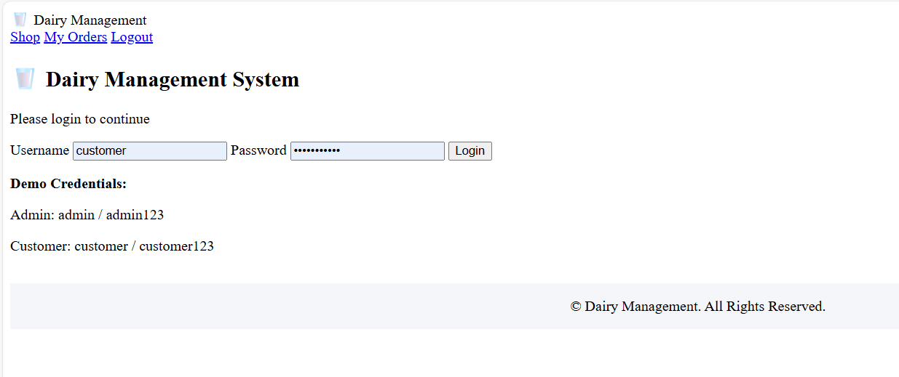

Admin Dashboard
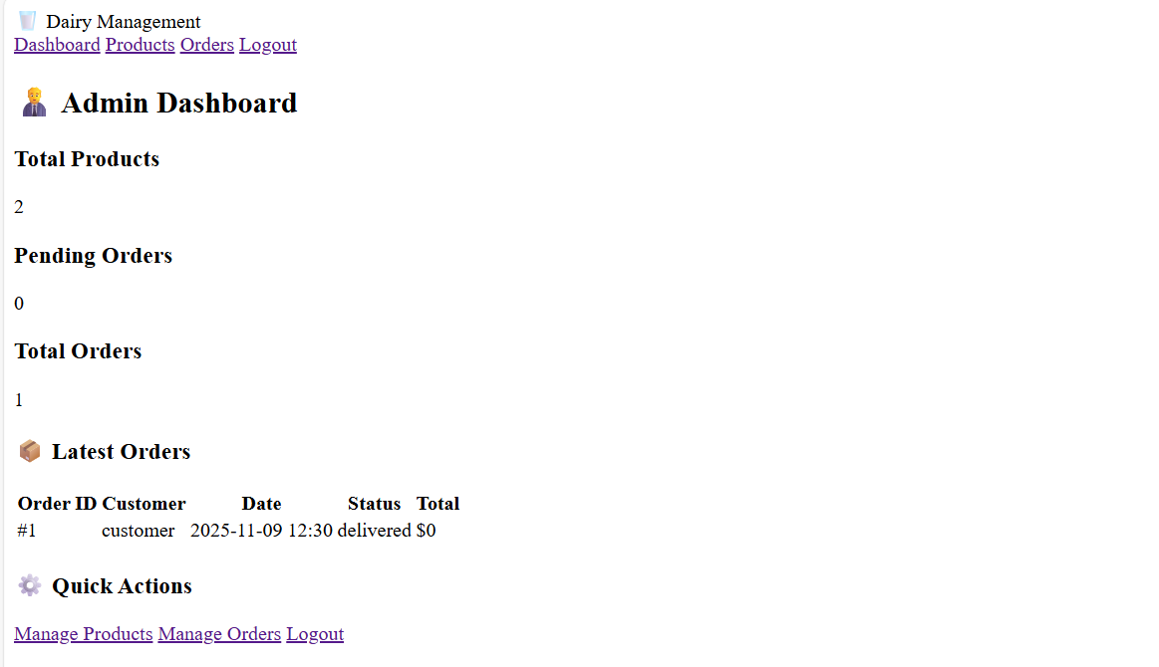

Customer interface
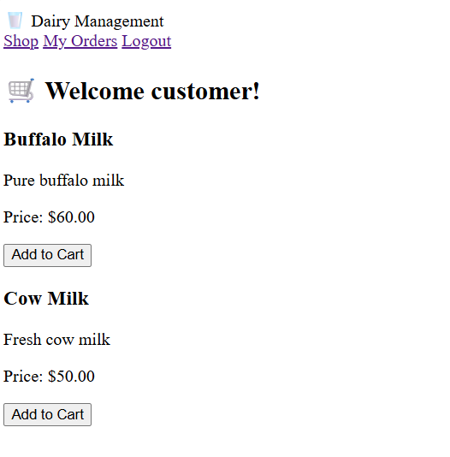

Order Summary
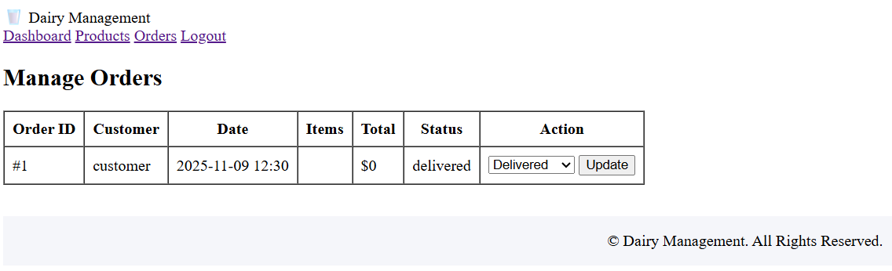
10. TESTING
Functional Testing
- Login
- Product CRUD
- Order placement
- Admin updates
User Interface Testing
- Navigation flow
- Broken link checks
Database Testing
- Data stored correctly
- Order relationships valid
Security Testing
- Prevent unauthorized admin access
- Password hashed
Performance Testing
- Fast page loading
- Optimized queries

11. RESULTS
The developed system successfully replaces manual dairy management processes with a digital solution. Admins can manage products, track orders, and update statuses. Customers benefit from transparent order tracking. The database stores records reliably, improving operational efficiency.
12. CONCLUSION
The Dairy Management System provides a functional, secure, and scalable web application for dairy operations. With Django as the backbone, the system offers modularity and ease of expansion. The project proves the capability of web technologies in modernizing traditional dairy processes.
13. FUTURE ENHANCEMENTS
- Milk collection module for suppliers
- Automated digital billing
- Android app integration
- IoT milk measurement system
- Daily payment SMS alerts
- Multi-branch dairy support
- AI-based forecasting of milk demand
14. REFERENCES
• https://docs.djangoproject.com/
• https://getbootstrap.com/
• https://www.sqlite.org/
• https://www.w3schools.com/
• https://developer.mozilla.org/
• https://www.tutorialspoint.com/django
• https://stackoverflow.com/

